[ Insert official UPAEP logo ]
UPAEP · Decanato de Ingenierías
EVIDENCE — US10-T5
Test threshold configuration
SmartGreenAI: Cilantro Crop

1. Task information
Task ID | US10-T5
User Story | US-10 — Configure sensor thresholds
Sprint | Sprint 2 (2026-09-21 – 2026-10-09)
Week | Week 3
Responsible | Jorge Velez Delgado
Peer reviewer | Alexis Enrique Valle Parra
Planned / actual hours | 2 h / 2 h
Completed on | October 8, 2026
Status | Done

2. Task description
Test create, edit, invalid values (min greater than max, empty, text) and access by a Producer user (must be denied).

3. Completion conditions
✓ Condition 1: Create, edit and invalid-value cases executed.
How it was verified: Create, edit and the invalid values (min greater than max, empty, text) were executed on the screen and against the API.
API calls of the test (attached: US10-T5_Test_Threshold_Configuration_4.txt)
POST /api/thresholds
Authorization: Bearer eyJhbG…
{
"area_id": "AREA-2",
"sensor_type": "co2",
"min_value": 420,
"max_value": 950,
"unit": "ppm",
"crop_stage": "test"
}
→ HTTP 201 Created (20 ms)
{
"id": "th-938f341da1",
"area_id": "AREA-2",
"greenhouse_id": null,
"crop_stage": "test",
"updated_at": "2026-09-29T04:19:14.023Z",
"updated_by": "usr-admin",
"parameter": "co2",
"sensor_type": "co2",
"min_value": 420,
… (5 more lines in the attached file)
PUT /api/thresholds/th-938f341da1
Authorization: Bearer eyJhbG…
{
"min_value": 400,
"max_value": 1000
}
→ HTTP 200 OK (23 ms)
{
"id": "th-938f341da1",
"area_id": "AREA-2",
"greenhouse_id": null,
"crop_stage": "test",
"updated_at": "2026-09-29T04:19:14.047Z",
"updated_by": "usr-admin",
"parameter": "co2",
"sensor_type": "co2",
"min_value": 400,
… (5 more lines in the attached file)
PUT /api/thresholds/th-a1-soil-moisture
Authorization: Bearer eyJhbG…
{
"min_value": "sixty",
"max_value": 80
}
→ HTTP 400 Bad Request (15 ms)
{
"status": 400,
"code": "ERR_VALIDATION_FAILED",
"message": "The submitted data does not match the required schema.",
"details": [
{
"field": "min_value",
"issue": "Expected number, received string"
}
]
… (1 more lines in the attached file)
PUT /api/thresholds/th-a1-soil-moisture
Authorization: Bearer eyJhbG…
… (17 more lines)

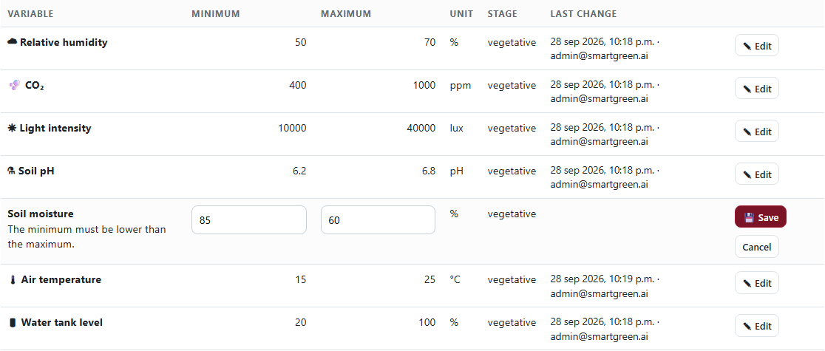
Figure US10-T5-1. Minimum greater than maximum: "The minimum must be lower than the maximum." (US10-T5_Test_Threshold_Configuration_1.png)
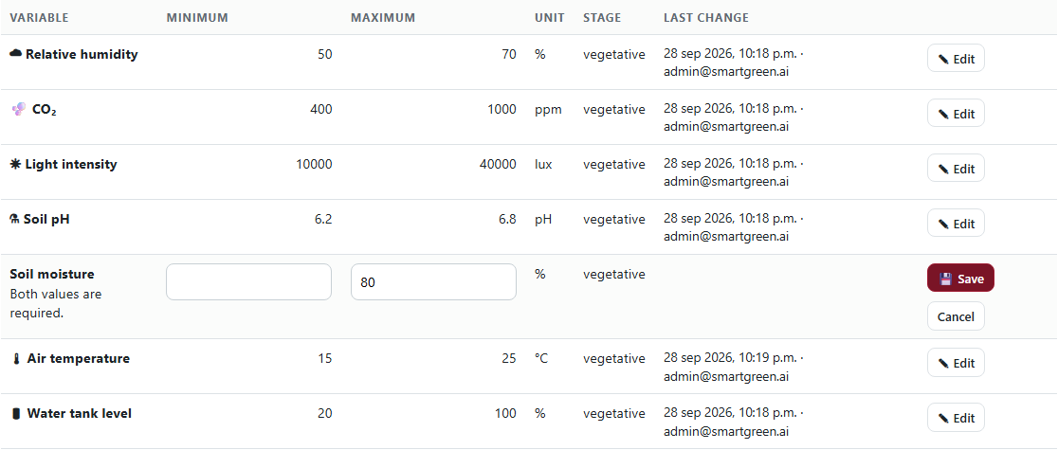
Figure US10-T5-2. Empty value: "Both values are required." (US10-T5_Test_Threshold_Configuration_2.png)
✓ Condition 2: Producer user cannot modify thresholds.
How it was verified: The Producer cannot modify thresholds: the API answers 403 and the screen is not reachable for the role.
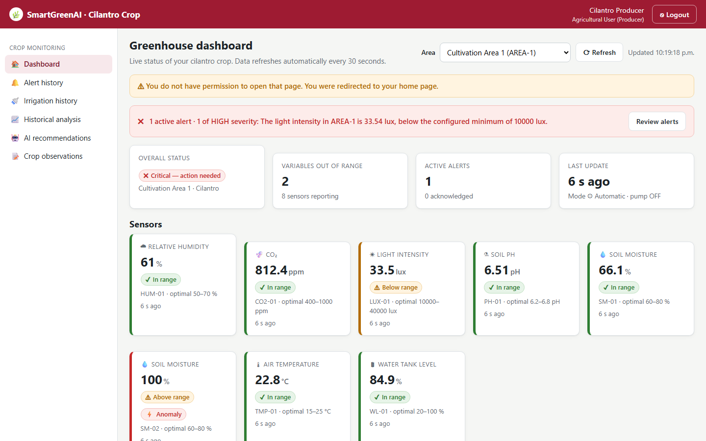
Figure US10-T5-3. Producer opening the threshold screen: redirected to the dashboard with a permission warning. (US10-T5_Test_Threshold_Configuration_3.png)
✓ Condition 3: Results and screenshots saved as evidence.
How it was verified: Results and screenshots are saved in the evidence folder (test table below and attached files).
✓ Condition 4: Evidence: Test cases with results and screenshots.
How it was verified: Test cases with results and screenshots.

4. Threshold configuration test cases
ID | Case | Steps | Input | Expected | Actual | Result
TH-01 | Create threshold | POST /thresholds as Administrator | AREA-2 CO₂ 420–950 | 201 created | HTTP 201 | PASS
TH-02 | Edit threshold | PUT /thresholds/{id} | 400–1000 | 200, values stored | HTTP 200, 400–1000 | PASS
TH-03 | Minimum greater than maximum | Edit soil moisture row on the screen and press Save | min "85", max "60" | rejected with a message, nothing saved | The minimum must be lower than the maximum. | PASS
TH-04 | Empty value | Edit soil moisture row on the screen and press Save | min "", max "80" | rejected with a message, nothing saved | Both values are required. | PASS
TH-05 | Text instead of a number | PUT /thresholds/{id} with a string | min_value "sixty" | 400 ERR_VALIDATION_FAILED | HTTP 400 ERR_VALIDATION_FAILED | PASS
TH-06 | Producer modifies (API) | PUT /thresholds/{id} with the Producer token | 55–80 | 403 | HTTP 403 ERR_INSUFFICIENT_PERMISSIONS | PASS
TH-07 | Producer opens the screen | Producer navigates to /admin/thresholds.html | producer session | redirected, cannot edit | redirected to /producer/?denied=1 | PASS
TH-08 | Nothing changed by rejected cases | Query the soil-moisture threshold | SQL | 60–80 | 60.000–80.000 | FAIL
Totals: 8 cases · 7 PASS · 1 FAIL

5. Attached files
- US10-T5_Test_Threshold_Configuration_1.png
- US10-T5_Test_Threshold_Configuration_2.png
- US10-T5_Test_Threshold_Configuration_3.png
- US10-T5_Test_Threshold_Configuration_4.txt

6. Traceability
Related requirements | FR-12, NFR-06
Implementation | See docs/TRACEABILITY.md
Verification | See docs/TRACEABILITY.md

7. Sign-off
Role | Name | Date | Signature
Responsible | Jorge Velez Delgado | October 8, 2026
Peer reviewer | Alexis Enrique Valle Parra | October 8, 2026
Product Owner acceptance | Alexis Enrique Valle Parra | October 8, 2026

